Active Directory Scope and Objective Alignment Meeting

Thursday, November 18, 2021

Logs are checked for 3 days prior. Sat, Sun (Checked on Monday)

Machine generated alternative text:
New Search 
index—eph "Error creating GID/GID Link Entry" 
O events (11/17/21 AM to 11/18/21 AM) 
Save As 
Create Table View 
Yesterday 
Close 
No Event Sampling • 
Job 
Events (O) 
Patterns 
Format Timeline • 
Statistics 
— Zoom Out 
Visualization 
+ Zoom to Selection 
No results found. Try expanding the time range. 
Smart Mode • 
1 hour per column 

Showing what is captured in splunk.

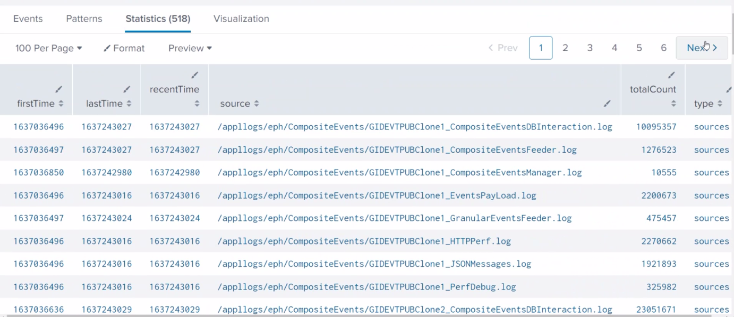

Nijesh will export log and send.

**Do we have this for Guardian?**

Not at all, guardian shows different section for creating logs.

Machine generated alternative text:
New Search 
I metadata type—sou ces index=eph 
518 results (11/17/21 AM to 11/18/21 AM) 
Save As • 
Close 
No Event Sampling • 
Job 
Yesterday 
Smart Mode • 
Events 
Patterns 
Statistics (518) 
100 Per Page • 
firstTime 
1 637036496 
1 637036497 
1 637036850 
/ Format 
lastTime 
1 637243027 
1637243027 
1 637242980 
Preview 
recentTime 
1 637243027 
1 637243027 
1 637242980 
Visualization 
source A 
2 
3 
4 
5 
6 
/ appllogs/ eph/Compos i one 1 _Compos i teEventsDBInte ract i on. log 
/app110gs/eph/Composi teEvents/GIDEVTPUBC10ne1 _ Composi teEventsFeeder. log 
/ app110zs/eph/Compos i teEvents/GIDEVTPUBC10ne1 _ Compos i teEventsManazer . loz 
totalCount 
10095357 
1276523 
10555 
Next > 
type 
sources 
sources 
sources 

The metadata for all the logs (above screenshot)

Alerts are system functionality, nothing to do with data. It's alerts for IT system individuals.

Data stewards own the data, functionality of the data. Alerts are more IT functions.

**Who is responsible for defining the system performance alerts when event is triggered?**

* Goes to the EPA group. they will inform us that they are reaching capacity.

**Who decided 90 percent?**

* Guess this is a companywide standard.
* Typically they set up alerts for the entire enterprise. For UniX for example, they say 70% percent.

**Once an alerts is triggered, defined SLAs?**

* Depends, typically resolved within 24 hours. Non critical, 1-3 business days (meaning just soft warning)

**So there is priority level?**

* Not really. Based on the nature of the application. Each application based on experience level, leave to application team for when they want to solve it.
* Database for instance, 1.5 terabyte size.

**Order of how the capacity plan takes place?**

* We give the report to them end of every month. Do not know what they do after that. Provided 12th of every month.

**Business is responsible for the quarterly decks?**

* I don't know, but they provide the information.

DOCUMENT REQUEST

Please provide all four quarterly reports and their associated monthly reports from 4th Quarter of 2020 to 3rd Quarter of 2021 for the following sources: RxConnect and RxClaim.

You do quarterly reports?

* No we do monthly.
* We do not fill out any spreadsheets.

Who is responsible?

Machine generated alternative text:
RE: EPH Audit - Risk control Analysis (RCA) validation 
Vazquez. Sol 
Cc 
Thank pu Wijendran. mreciate your rev*w and edits. Regarding the last two iterns. we have several ot followup westms, please see 
AS to SYStgn performance : 
Who is responsible for defining the system *rfMmance alerts and conf*uring them the system'? 
an alert are there SLAS the alerts? If so, please provide the SLAS for each specific 
Please confi the of how the entire p p p from whenfhe monthly data Is) is to when takes place with the bu system) — update if this 
transactional data (actuXS) is extracted and to 
by Hour is extracted and Sent to business 
EPH team fills in the metrics table Capuity Plannirw Reqt•st email 
dec:k created by business 
Stuage size increase is by the EPH Team and Infrastructure 
Val i d ati*' Checks are by EPH Team and to *'formed 
Thank 

Machine generated alternative text:
of AMS 
Peak Daily Adds 
'Of month 
peak Daily Updates 
of D&tes n-,onth 
Peak Daily 
peak Sir* per day 
of Searches 
a Searches 
of MLAti Key 
peak Searches 
Total 
1,288Aso 
3586.083 
258,571 
34085 
8,061 ma 
2,622.920 
733.069 
41.268 
11,614.140 
3749113 
2,377.408 
s, 987,806 
45-0A89 
785.540 
22. IOS 
228.916 
17103 
699,833 
21,201 ma 
1,531.5m 
3, 794,tBa 
1,044.111 
type 
Real Tin* 
Real 
Real 
Real Time 
Real Time 
Real Time 
Digital 
Rxconnect 
Has 
CATS 
Aetna 
DIGITAL 
8,621.161 
"97,388 
23,401 
2.010309 
11, 70s 
19,227 
25,017 
2.202532 
440385 
2,4L9S0 
851,511 

Machine generated alternative text:
1) Alerts 
WAS 
DB alerts 
Wddkware JVM 
Microsoft 
PowerF 
Microsoft 
start 
L%/Server space full, other server realted 
t earn 
WAS 
Lin 
t earn 
Email 
Email & 
Phone 
Email & 
Email & 
Email 
Batch Job failures 
Splunk alerts 
ALL 
JOB 45 
BATCH FAILURE - Cau & EMAR 
Real time 
count i' greater than the job and it will alert the EPH team with 
•SOURCE AND REACHED THRESHCRO, 
PLEASE VALIDATE AND PAGt THE scnJRCE TEAM - 
transaction. "plication reponse Success with 
EPH CVS . i' 
which added. Rae"im on 
.ppli:.tion gets every on the outgoing 
event i' records. then the record i' sent 

It's not clear who creates the decks?

* That's from Steven wiklin's group.

Machine generated alternative text:
EPH (Enterprise Patient Hub) 
Business : Joe 
Business : Enterprise 
Ente'prise p 
VP Sign Off 
IT VP Signoff : 
EPH - Enterprise Patient Hub 
: VP Forecast : 
ForecÆt Pm ided By : 
Last Refresh Date : 
YOY 
•CVSHealth 

**How is increased determined?**

* Right now, we are 5 years. Based on the forecast given, based on current projection, we can see we are 5 years' worth of capacity space available.

Do you have retention of documents?

* We don't have retention. That's determined by Steven Wiklin's team.
* The database is set up for enough space to carry for another 5 years.

Data storage, there is cost associated with increase.

* When database was set up, it was set up with a lot of space for about 5 years from now.
* Data base has not increased since it's inception. No need for yearly increase.

Machine generated alternative text:
Data 
"db 
3760 G 
Avail 
17«JG 
'db rd/e 

Database in east and west are exactly mirror image.